Laporan Praktikum 2

1. Source Code

latihan1.php => controllers

latihan2.php => controllers

Model1.php => models

view_latihan2.php => views

1. URL

<http://localhost/pustaka_booking_rina/index.php/latihan1>

<http://localhost/pustaka_booking_rina/index.php/latihan2/penjumlahan/5/7>

1. Capture Output Program

Latihan 1

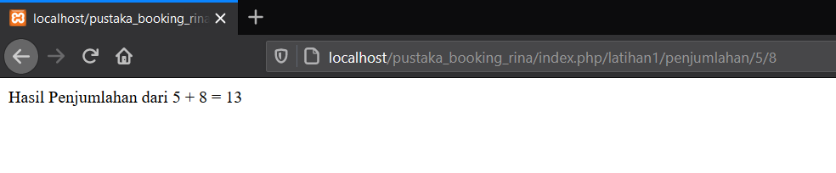

Latihan 2

